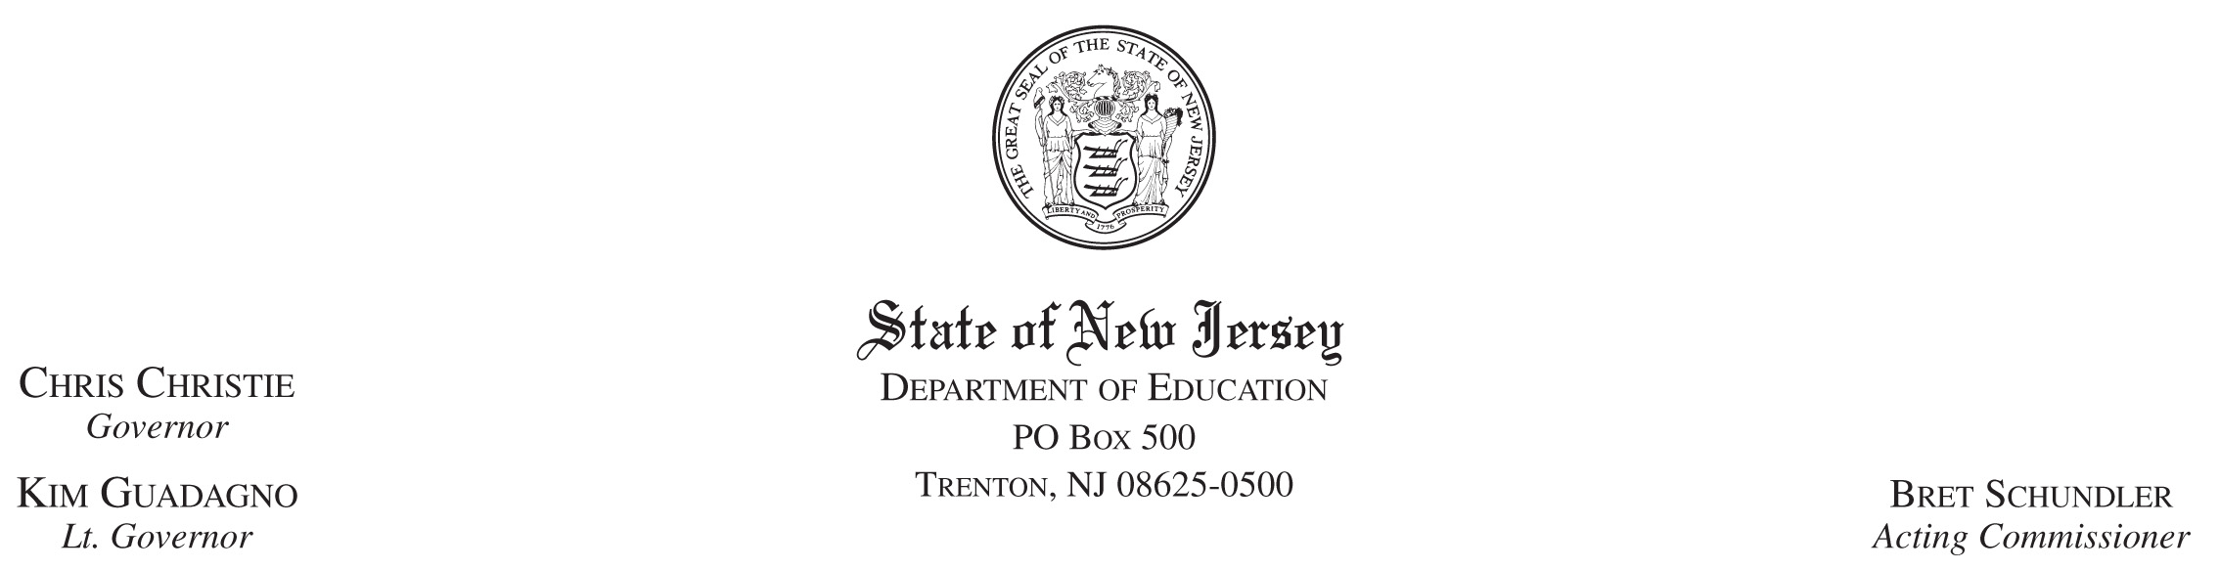

February 11, 2010

TO: District Superintendents
School Business Administrators
Board of Education Presidents

FROM: Bret Schundler, Acting Commissioner

SUBJECT: State Aid

On February 11, 2010, Governor Christie issued Executive Order No. 14, which declares a fiscal emergency in the State of New Jersey. State revenues have fallen far short of the level projected when this year’s budget was adopted. Given the short time left in this fiscal year, and the fact that school aid comprises such a significant portion of the State budget, it has become necessary for the State to reserve some of the remaining school aid payments that school districts have been slated to receive.

Specifically, the Executive Order directs me to reserve district state aid payments based on the amount of surplus and reserve account monies available to each district. Its goal is to ensure that no district is forced into a deficit situation due to this withholding, so each district can continue to provide a thorough and efficient education to its students.

The amount of aid reserved from each district was determined using information from its 2008-2009 Audit Summary and its 2009-10 Original Budget. We have attached the amount of excess surplus, reserve account balances, and underestimated balances that were used for this calculation, and the total amount of aid that is being reserved from your district and others in your county. If your district had activity between July 1, 2009 and February 10, 2010 which changed the amount available in these categories, or if your district believes that it submitted incorrect data, or if you disagree with the amounts listed herein for any reason, you may seek adjustment by application to your Executive County Superintendent no later than February 22, 2010. The Executive County Superintendent will, in turn, make a recommendation to me relating to the requested adjustments by February 26, 2010. Applications for adjustment must include documentation that supports the claim, and the district must demonstrate that it has complied with regulatory and/or statutory requirements for the transfer of funds out of surplus or reserve accounts. Additional guidance relating to this matter can be found in your DOE Homeroom folder.

Again, we have sought to ensure that no district suffers an aid reduction it cannot offset through the use of surplus balances and reserves that are available to it. All districts have the ability to transfer funds from their surplus, emergency and maintenance reserves to meet operational costs for this school year. In your DOE Homeroom folder, you will find checklists derived from N.J.A.C. 6A:23A-13.3 that set forth the steps and documentation required to apply for a transfer from surplus before April 1, 2010, and after April 1, 2010. Steps are also outlined for a request of transfer from reserve accounts. In those instances where Commissioner approval is required for a transfer, districts must first seek transfers of excess surplus, unreserved and undesignated surplus, and emergency reserves. I can only approve a transfer from your maintenance reserve or capital reserve if no other revenue sources to address the shortfall are available, and the transfer is necessary to meet the constitutional requirement of a thorough and efficient education.

With questions about your district’s surplus or reserve amounts, please contact the Division of Finance, Office of School Funding at staid@doe.state.nj.us (or call 609-984-4949). With questions about the procedure for withdrawing funds from your district’s balances and reserves, contact the Office of Fiscal Policy and Planning at doecafr@doe.state.nj.us (or call 609-292-3496).

Attachments

